**BRIDGE TE AROHA: lovely place, lovely game ♠♥♦♣**

**Te Aroha News February 2025**

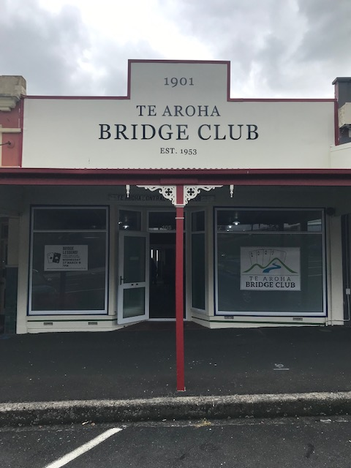 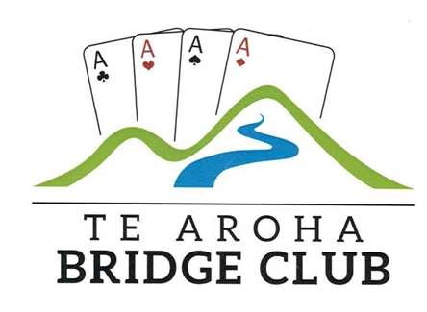

**International Champions**

That’s Rochelle and Tim after their success in the Intermediate section of the Teams at the Gold Coast Bridge Congress. They had been close to success in this event last year but their last round let them down. Not so this time as with Mt Albert’s Bigi Cameron and Emma Russell, they qualified from the 12 match Swiss qualifying event in 2nd place, a very good effort in itself as there were 88 teams in the event.

The final was a bit up and down but then really “up” at just the right moment. In the 4 sets of 12 boards, they led 33-0 after the first set and 43-21 after the second. Storm clouds gathered as they lost the third set 14- 47 to trail by 11 going into the last 12 boards. There was to be no “choking” this time as 2 game and 1 slam swing all went their way and they won the last set 41-3 to win overall 98-71, a very clear margin.

While those on the Coast from the club (in addition to Tim, Rochelle… Victor, Guy, Anna and yours truly, along with Tim’s wife, Kristin) had been celebrating every night, this night was an extra special celebration. Tim and Rochelle have previously won several “dress-ups” at this Congress. This year, success deservedly came at the table.

**International Champions**

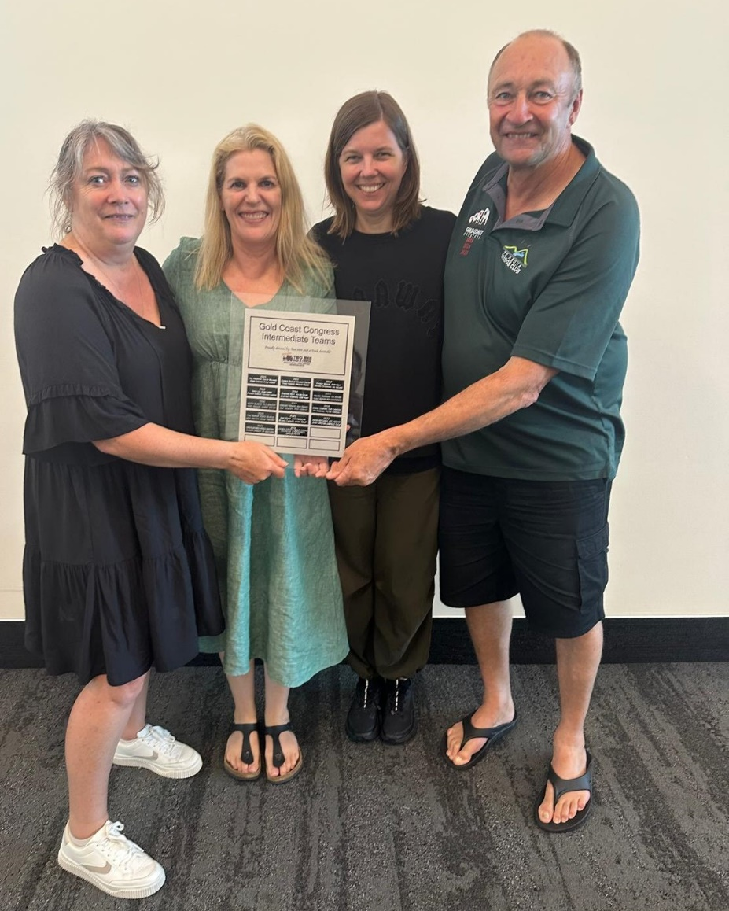   
*Rochelle, Emma, Bigi and Tim with their trophy. Rochelle was really as happy as the others. She just did not show it!*

They also did pretty well in the Ivy Dahler Pairs, finishing 2nd in the B Grade. There were 5 Intermediate sections with each section having 28 pairs. They averaged just over 58% over the 3 x 27 board sets in the final and finished just 1.28% over the three sessions behind the winners.

They took “centre stage”. Anna and I finished 6th in the D section of the Open Pairs (there were 9 sections of 28 pairs), 50th out of 164 teams in the Open Teams and 34th out of 118 pairs in the Open Swiss Pairs.

In the Intermediate Pairs, Guy and Victor finished half way in the D Section and 39th in the Intermediate Teams, respectible finishes.

Before we leave the “serious” part of the Congress, a small word of mention to our number 1 and 2 fans. I will name them in alphabetical order and they can assign their positions. Barbara and Alan (is that “alphabetical? 😊) kept a very close watch on how we were doing and we heard the cheers all the way in Surfers coming from Matamata and Paeroa when Rochelle and Tim won the Teams.

**The Te Aroha Team at this year’s Gold Coast Congress**

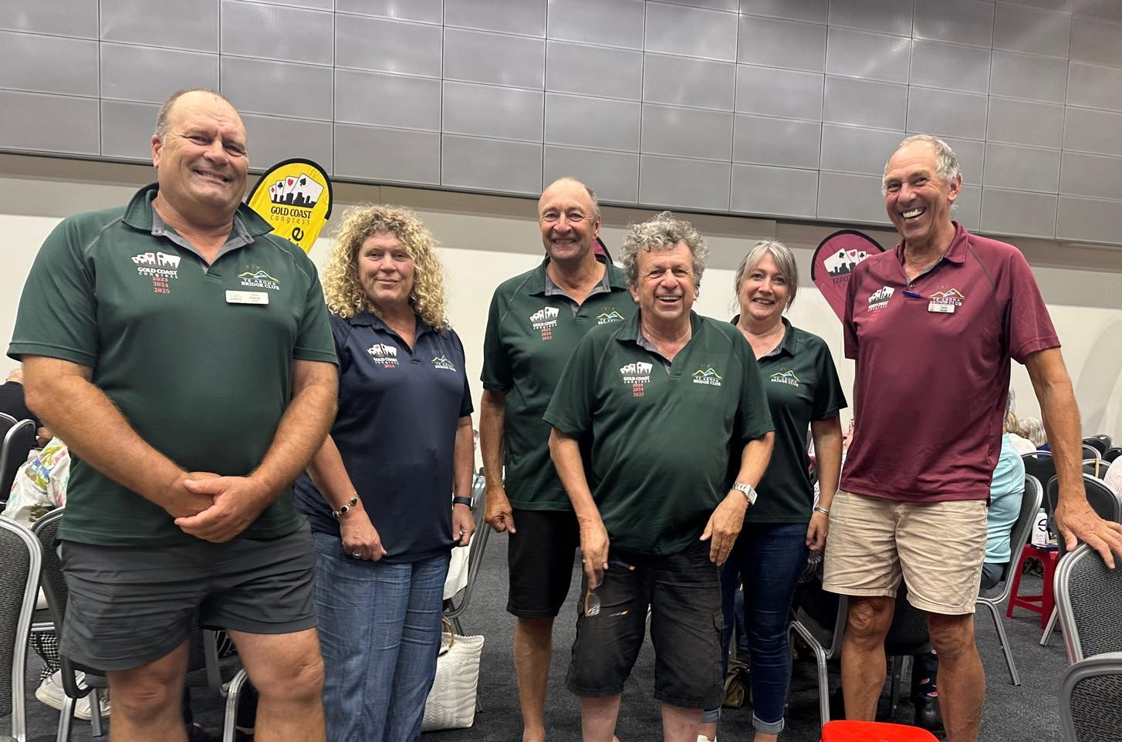

**Who said it was all pleasure!** 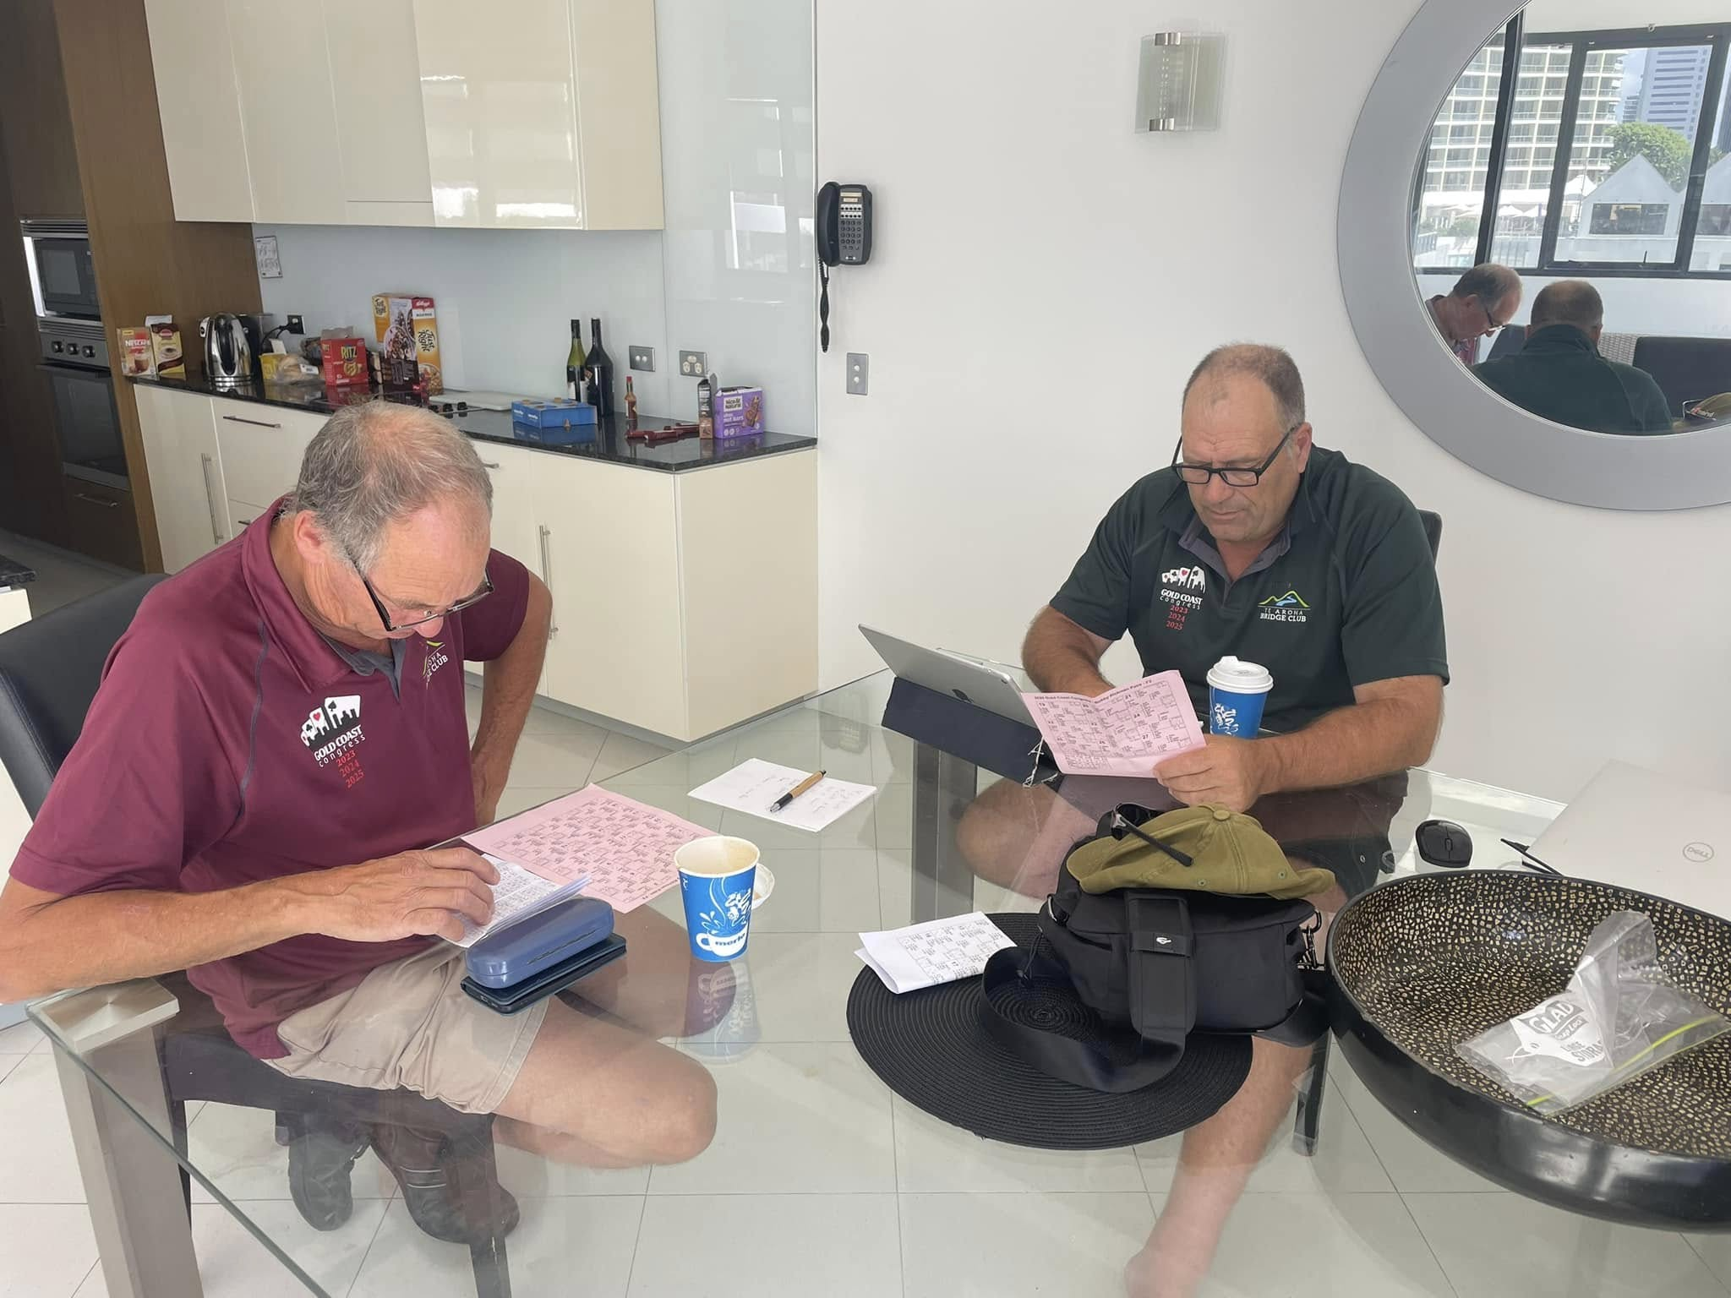

*Victor and Guy hard at work analysing what went right..and what did not!*

**And when the bridge was over…**

We did have a very good time over there. Great accommodation situated seconds away away from a host of wonderful restaurants, and just a 5 minute walk to both beach and the Convention Centre. Oh, some of the group who shall remain nameless (I can be bribed to tell all!), ventured into the casino and left with more money than with what they started!

On another day, four keen players just succeeded to get out of the “Escape Room”. You have an hour to solve the clues that lead to your escape. Who knows? Had we not “escaped” with seconds to spare, I could still be sharing a small cell with Victor, Tim and Rochelle. Phew!

A small mention on the night at Draculas’ theme restaurant and stage show, to celebrate the birthday of one of the group. Guess who? Finally, our honorary member, Kristin, spent a reasonable amount of time at the local shops. That interested her far more than spending days at the bridge table.

There was no real dress- up at this year’s Congress but….

**Black Wednesday**

**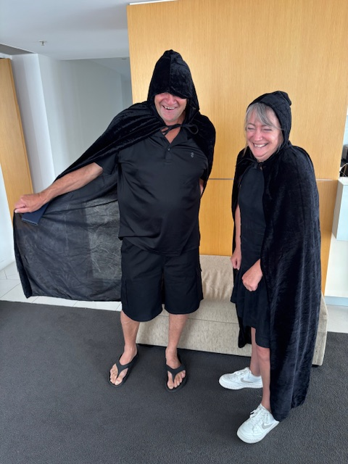***How could you be scared with those smiley faces there, even if they were “dressed in black”!*

As the organisers have been unable to secure a booking for next year, this year’s may have been the last Gold Coast Congress. It was the 63rd. Therefore, on the dress-up day, everyone dressed up in black, in mourning. Let’s hope this excellent Congress returns in the not too distant future.

**2025 Winners at the Club**

Congratulations to the first Tuesday champs this year. In the 3 Night Individual Pairs, we had Malcolm just beating Hannah by a mere 0.87% while in the Handicap competition, Peter TJ beat Joan by over 8%.

Meanwhile, the Protag Swiss Pairs went down to the wire. Laurie and Jan had had a great 3 weeks but just led Ross McIntyre and myself by a little over 4 vps going into the last of the 9 matches. Both pairs had wins in their last match, with Laurie and Jan scraping a small win by 11.95 Vps. That proved enough as we could only manage 15.45 and victory went to Laurie and Jan by just 1.26 Vps…a nice victory for them. They were very consistent in winning 7 out of their 9 matches and occupied 1st place throughout the last 2 weeks of the event. Thanks once again to Tyrel and Charlotte for sponsoring this event.

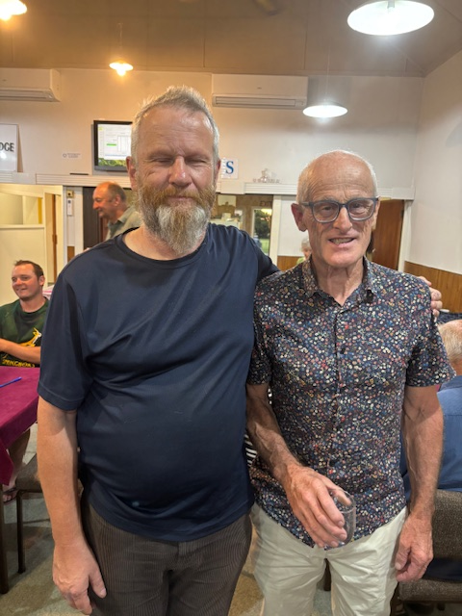 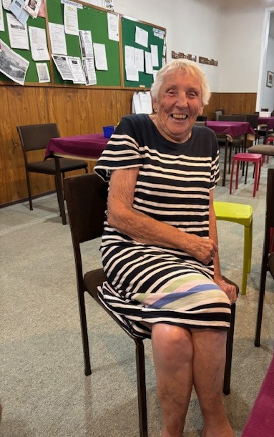

*3 week Individual winners: and Laurie celebrated her success with*

*Off scratch and Handicap a glass of port. Jan was celebrating at home*

**Showing how it should be done**

That’s Alan and Debbie who were the only “slammers” on the last night of the Protag Swiss Pairs.

|  |  |  |  |  |  |  |  |  |  |  |
| --- | --- | --- | --- | --- | --- | --- | --- | --- | --- | --- |
| *Board 1* North Deals None Vul | |  |  | | --- | --- | | ♠ | K | | ♥ | A J 5 2 | | ♦ | A K Q 5 4 2 | | ♣ | A 4 | | |
| |  |  |  |  |  |  |  |  |  |  | | --- | --- | --- | --- | --- | --- | --- | --- | --- | --- | | |  |  | | --- | --- | | ♠ | Q 7 6 3 | | ♥ | 7 | | ♦ | 7 | | ♣ | Q 9 8 7 6 5 2 | |  | | |  |  |  | | --- | --- | --- | | N | | | | W |  | E | | S | | | | |  |  |  |  |  |  |  |  |  |  | | --- | --- | --- | --- | --- | --- | --- | --- | --- | --- | |  | |  |  | | --- | --- | | ♠ | A J 10 9 8 2 | | ♥ | 10 9 6 4 3 | | ♦ | 10 | | ♣ | 3 | | |
|  | |  |  | | --- | --- | | ♠ | 5 4 | | ♥ | K Q 8 | | ♦ | J 9 8 6 3 | | ♣ | K J 10 | | |

|  |  |  |  |
| --- | --- | --- | --- |
| *West* | *North* | *East* | *South* |
|  | 2 ♣ | Pass | 2 NT |
| Pass | 4 ♦ | Pass | 6 ♦ |
| All pass |  |  |  |

Debbie opened a game-forcing 2C and Alan showed a positive response with 2NT, a balanced hand. When Debbie jumped in diamonds, Alan did not mess around. After SA lead, Debbie could ruff the spade continuation, draw trumps and claim the rest of the tricks.

At other tables, East-West got in the way in the bidding. Most North-South satisfied themselves with 5D and a couple of East-Wests found that 5S was a very cheap sacrifice, only one down. Well bid, Debbie and Alan.

**Flash Trash!**

What a classy club we are as demonstrated by the new bins Shirley B has acquired for the club.

**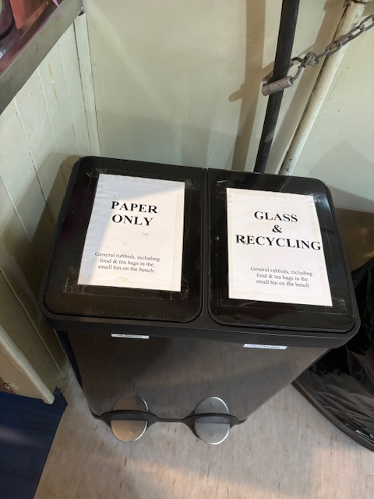***Now,**you know what goes in each bin, don’t you!*

**It’s Nearly Lesson Time.**

That is for our new players. Tyrel and Charlotte are again running the lessons and start date is Thursday March 27th at 7.00pm. $40.00 per player which includes this year’ sub. Now, you surely know someone around town who could be (gently) coerced into coming. Just have a think and then pick up your phone and call them.

..and we have a stand at **Domain Day** on Sunday March 9th where we will have a table set up to demonstrate the game. We still a few more players to put up their hands to come along and play.

The only requirements are to be happy and enthusiastic. So, let me know if you can come along either from 10.00 am until midday or from midday until 2.00pm. Please.

**Nice One, Gerry**

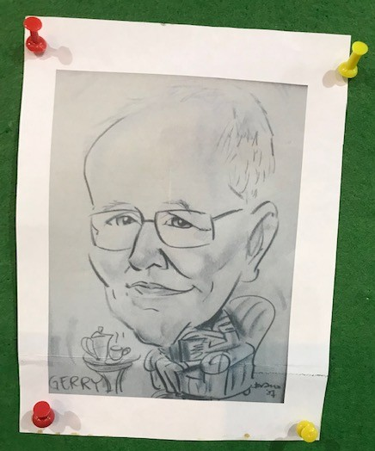

I think you should all know who this is and Gerry has a place on the club notice-board. Nice always to see you at Friday bridge, Gerry. I like the sketch and thought it worth reproducing here.

**Up-coming events at the Club.**

**Sunday April 27th Waikato Area Pairs** 2 session event…. Not just for Open players but for Intermediates and keen Juniors too. If you would like to play and need a partner, just let me know. Cost $15.00.

**Saturday June 8th Spa Town Teams and Restricted Swiss Pairs** Restricted Swiss is for those National Masters and lower rank. It is always a great day’s bridge at the Silver Fern Farm Events Centre.

And if playing is not for you, we will need helpers for both events..in the kitchen in particular. Let me know if you are available for either event…but we would love to see lots of you at the table.



**Tossing.**

Just one request from the Club Committee. When we are playing a Pairs session, please toss with your opponents at the start of the session with the winner of the toss to sit North-South.

Naturally, if a player needs to sit North-South or indeed needs to move rather than be stationary, then that will override the toss.

Oh, a coin like the above is not allowed! Heads one side and tails the other!

**The Wisdom of Solomon**



**Give Partner a Choice..if you can!**

This may not apply to you. You would not do this, would you? However, it recently happened to my opponents. So, it is worth mentioning.

What is your next bid as East in this sequence?

|  |  |  |
| --- | --- | --- |
|  |  |  |
| |  |  | | --- | --- | | West Deals None Vul |  | | |  |  |  | | --- | --- | --- | | N | | | | W |  | E | | S | | | | |  |  |  |  |  |  |  |  |  |  | | --- | --- | --- | --- | --- | --- | --- | --- | --- | --- | |  | |  |  | | --- | --- | | ♠ | 10 4 2 | | ♥ | A 9 8 5 | | ♦ | K | | ♣ | A Q 10 8 7 | | |

|  |  |  |  |
| --- | --- | --- | --- |
| *West* | *North* | *East* | *South* |
| Pass | Pass | 1 ♣ | Pass |
| 1 ♦ | Pass | ? |  |

“How short was 1C” you might ask? I will answer by saying it does not matter.

My opponent (and before you start wondering who this was…it was not at Te Aroha!) chose 2C….and look what happened:

|  |  |  |  |  |  |  |  |  |  |  |
| --- | --- | --- | --- | --- | --- | --- | --- | --- | --- | --- |
| West Deals None Vul | |  |  | | --- | --- | | ♠ | K Q 8 7 | | ♥ | K Q 10 3 | | ♦ | 8 7 6 5 2 | | ♣ | — | | |
| |  |  |  |  |  |  |  |  |  |  | | --- | --- | --- | --- | --- | --- | --- | --- | --- | --- | | |  |  | | --- | --- | | ♠ | A J 5 | | ♥ | J 7 6 4 | | ♦ | Q J 10 9 3 | | ♣ | 9 | |  | | |  |  |  | | --- | --- | --- | | N | | | | W |  | E | | S | | | | |  |  |  |  |  |  |  |  |  |  | | --- | --- | --- | --- | --- | --- | --- | --- | --- | --- | |  | |  |  | | --- | --- | | ♠ | 10 4 2 | | ♥ | A 9 8 5 | | ♦ | K | | ♣ | A Q 10 8 7 | | |
|  | |  |  | | --- | --- | | ♠ | 9 6 3 | | ♥ | 2 | | ♦ | A 4 | | ♣ | K J 6 5 4 3 2 | | |

|  |  |  |  |
| --- | --- | --- | --- |
| *West* | *North* | *East* | *South* |
| Pass | Pass | 1 ♣ | Pass |
| 1 ♦ | Pass | 2 ♣ | Pass |
| Pass | Dbl | All pass |  |

The double asked South to bid but with 7 clubs, South chose to defend. After H2 lead, this contract was defeated by 2 tricks, +300 for North-South.

Sure, the 7-0 trump break was unlucky but it should teach East a lesson. They should have bid 1H and West would bid 2H and there matters should rest. 2H is not an easy contract to play but far easier than 2Cx. Offer your partner a choice of suits especially if one of them is a major suit.

Happy Bridging. Richard